**Chapter 3**

**Vector-Valued Functions**

**3.1 Vector-Valued Functions and Space Curves**

**Section Exercises**

1. Give the component functions  and  for the vector-valued function 

Answer: 

1. Given  find the following values (if possible).
2. 
3. 
4. 

Answer: a.  b.  c. Undefined

1. Sketch the curve of the vector-valued function  and give the orientation of the curve. Sketch asymptotes as a guide to the graph.

Answer:

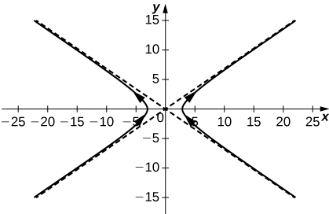

1. Evaluate 

Answer: 

1. Given the vector-valued function  find the following values:
2. 
3. 
4. Is  continuous at 
5. Graph 

Answer: a.  b.  c. Yes, the limit as *t* approaches  is equal to  d.

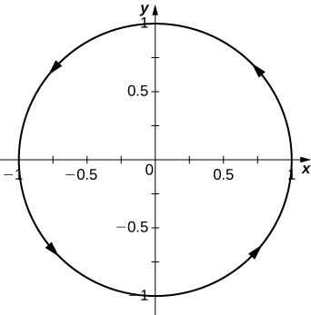

1. Given the vector-valued function  find the following values:
2. 
3. 
4. Is  continuous at 
5. 

Answer: a.  b.  c. Yes, d. 

1. Let  Find the following values:
2. 
3. 
4. Is  continuous at *t=*

Answer: a.  b.  c. Yes

**Find the limit of the following vector-valued functions at the indicated value of *t*.**

1. 

Answer: 

1.  for 

Answer: 

1. 

Answer: 

1. 

Answer: 

1. 

Answer: 

1.  for 

Answer: The limit does not exist because the limit of  as *t* approaches infinity does not exist.

1. Describe the curve defined by the vector-valued function

Answer: The line in space with direction vector 

**Find the domain of the vector-valued functions.**

1. Domain: 

Answer:  where k is an integer

1. Domain: 

Answer: 

1. Domain: 

Answer:  where *n* is an integer

**Let  and use it to answer the following questions.**

1. For what values of *t* is  continuous?

Answer: Continuous for all 

1. Sketch the graph of 

Answer:

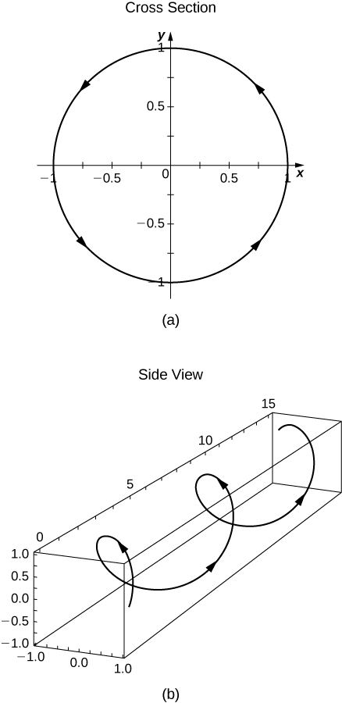

1. Find the domain of 

Answer: For all *t* such that 

1. For what values of *t* is  continuous?

Answer: All *t* such that 

**Eliminate the parameter *t* , write the equation in Cartesian coordinates, then sketch the graphs of the vector-valued functions.**

1.  (*Hint*: Let  and  Solve the first equation for *x* in terms of *t* and substitute this result into the second equation.)

Answer:  a parabola

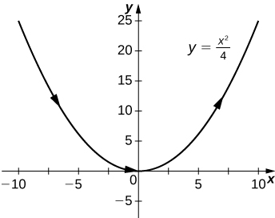

1. 

Answer:  a variation of the cube-root function

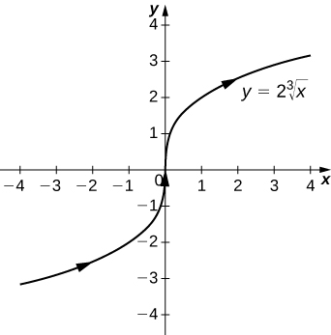

1. 

Answer:  the upper half of a hyperbola

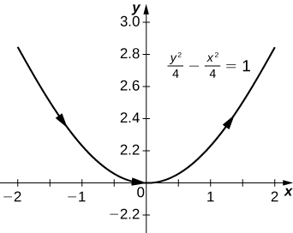

1. 

Answer:  a circle centered at  with radius 3, and a counterclockwise orientation

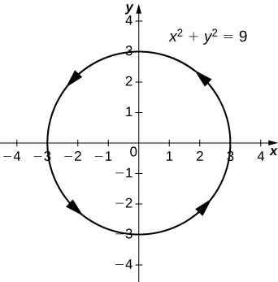

1. 

Answer:  a circle centered at  with radius 3, and a counterclockwise orientation



**Use a graphing utility to sketch each of the following vector-valued functions:**

1. **[T]** 

Answer:

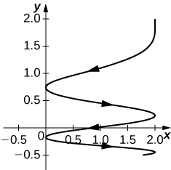

1. **[T] **

Answer:

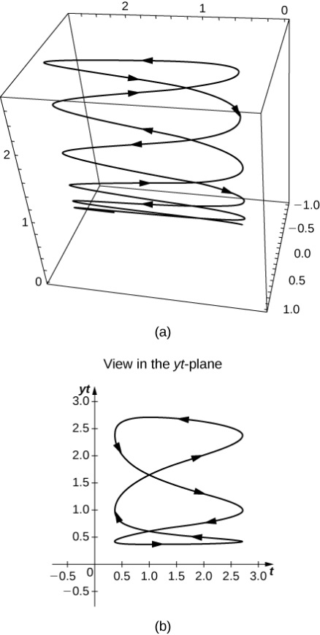

1. **[T] **

Answer:

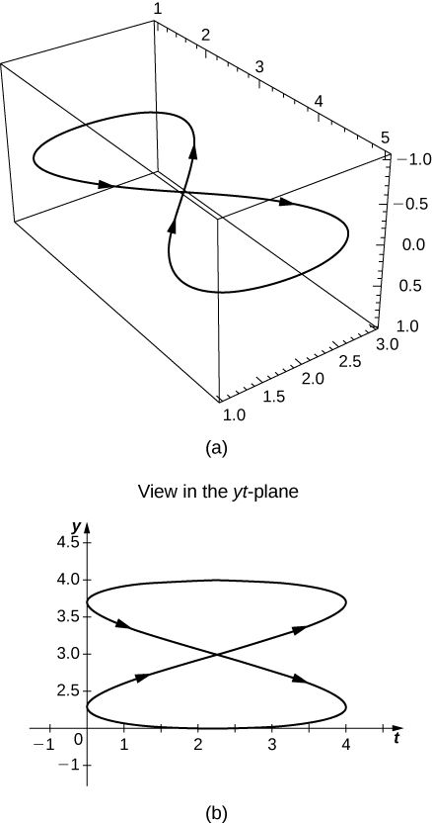

**Find a vector-valued function that traces out the given curve in the indicated direction.**

1.  clockwise and counterclockwise

Answer: For clockwise orientation,  for counterclockwise orientation, 

1.  from left to right

Answer: For left to right,  where t increases

1. The line through *P* and *Q* where *P* is  and *Q* is 

Answer: 

**Consider the curve described by the vector-valued function **

1. What is the initial point of the path corresponding to 

Answer: 

1. What is 

Answer: 

1. **[T]** Use technology to sketch the curve.

Answer:

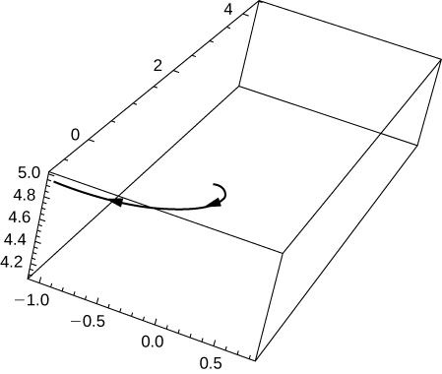

1. Eliminate the parameter *t* to show that  where 

Answer:   

1. **[T]** Let . Use technology to graph the curve (called the *roller-coaster curve*) over the interval  Choose at least two views to determine the peaks and valleys.

Answer:

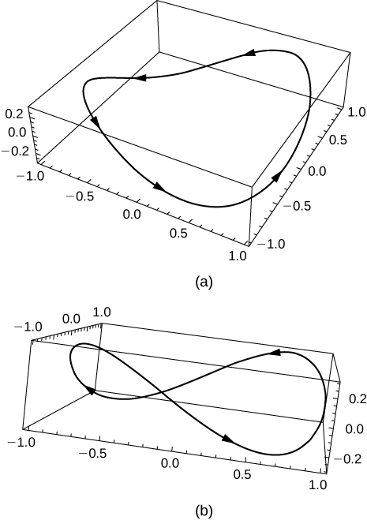

1. **[T]** Use the result of the preceding problem to construct an equation of a roller coaster with a steep drop from the peak and steep incline from the “valley.” Then, use technology to graph the equation.

Answer: One possibility among many: 

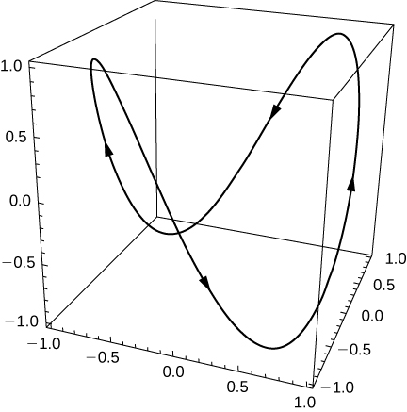

1. Use the results of the preceding two problems to construct an equation of a path of a roller coaster with more than two turning points (peaks and valleys).

Answer: One possibility is  By increasing the coefficient of *t* in the third component, the number of turning points will increase.

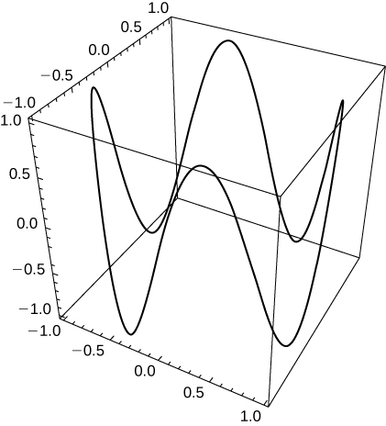

1. Graph the curve  using two viewing angles of your choice to see the overall shape of the curve.
2. Does the curve resemble a “slinky”?
3. What changes to the equation should be made to increase the number of coils of the slinky?

Answer: a.

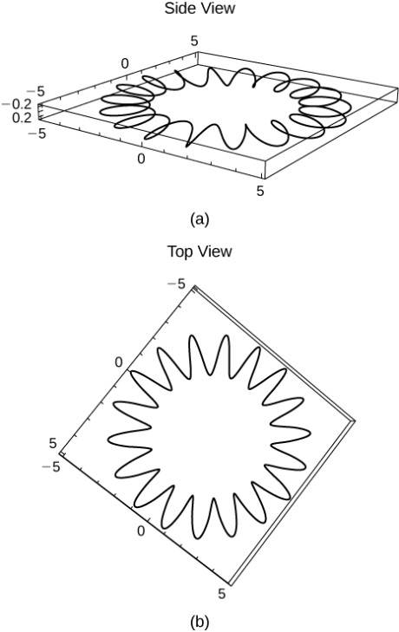

b. The curve resembles a slinky. c. To increase the number of coils, replace the coefficient 18 with a larger number.

This file is copyright 2016, Rice University. All Rights Reserved.